THIRD-PARTY APPLICATION TO USE TRADEMARKS
OF NATIONAL ASSOCIATION OF POSTAL SUPERVISORS

______________________________________ requests authorization to use the NAPS Trademark, as signified below:

 NAPS Historical Trademark – Certification Seal
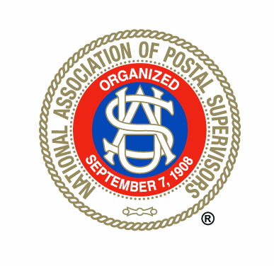

 NAPS Modern Trademark

Applicant requests authorization to use the NAPS Trademark(s) for the following purpose(s):

_________________________________________________________________________________________________

In applying for authorization, the applicant promises to use the signified trademark in accordance with all laws, rules and NAPS policies, including the following terms of use:

- The Trademark shall be used in a professional manner.

- The trademark, including the NAPS Certification Seal, may not be altered, redrawn, or reset typographically. Elements of the trademarks may not be separated, rearranged, or altered in any way, and original height-to-width proportions (aspect ratios) must be maintained.

- NAPS reserves the right to license its trademarks for fees and royalties in connection with third-party sale of goods and services bearing the trademark.

- Use of the trademarks may not violate the rights of others or applicable law, and may not state or imply NAPS’ endorsement of any business or organization without NAPS’ specific consent.

- Upon request from NAPS Headquarters, the Branch shall forward samples of use of the logos and graphics.

- Permission to use NAPS trademarks is revocable by NAPS.

______________________________________________ ______________________________________________
Name of Individual or Company Date

______________________________________________ ______________________________________________
Representative on Behalf of Company Position

______________________________________________
Signature

____________________________________________________________________________
Address/City/State/ZIP

_______________________________________ _______________________________________
Telephone Email

============================================================

The National Association of Postal Supervisors authorizes _______________________________________________________________________________ to use the requested NAPS Trademark(s) in accordance with all laws, rules and NAPS policies governing their use.

_______________________________________ ________________________________________ Name Title

_______________________________________
Date

